Pre-order your official Mountain Kids leo
by October 30th !
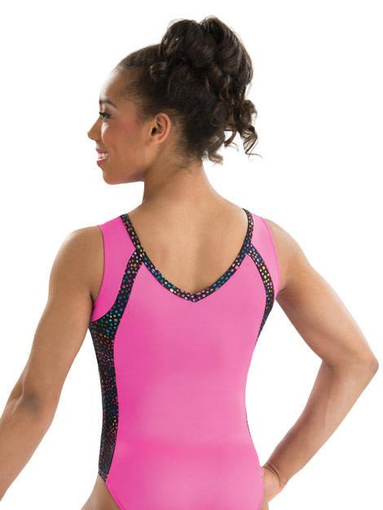

Perfect for your gymnast’s Winterfest Performance and Teddy Bear Meet – plus it’s as cute as can be!

Pre-Order Price: Until 10/30/15 = $44.95
After 10/30/15 = $49.95 (limited supply)

Gymnast’s Name: __________________________________

Size (please circle one): CXS CS CM CL
AXS AS AM AL

